Lucid X Series

Performance Verification Manual

Rev. 0.1

Warranty Statement

Products sold by Tabor Electronics Ltd. are warranted to be free from defects in workmanship or materials. Tabor Electronics Ltd. will, at its option, either repair or replace any hardware products which prove to be defective during the warranty period. You are a valued customer. Our mission is to make any necessary repairs in a reliable and timely manner.

Duration of Warranty

The warranty period for this Tabor Electronics Ltd. hardware is one year, except software and firmware products designed for use with Tabor Electronics Ltd. Hardware is warranted not to fail to execute its programming instructions due to defect in materials or workmanship for a period of ninety (90) days from the date of delivery to the initial end user.

Return of Product

Authorization is required from Tabor Electronics before you send us your product for service or calibration. Call your nearest Tabor Electronics support facility. A list is located on the last page of this manual. If you are unsure where to call, contact Tabor Electronics Ltd. Tel Hanan, Israel at 972-4-821-3393 or via fax at 972-4-821-3388. We can be reached at: support@tabor.co.il

Limitation of Warranty

Tabor Electronics Ltd. shall be released from all obligations under this warranty in the event repairs or modifications are made by persons other than authorized Tabor Electronics service personnel or without the written consent of Tabor Electronics.

Tabor Electronics Ltd. expressly disclaims any liability to its customers, dealers and representatives and to users of its product, and to any other person or persons, for special or consequential damages of any kind and from any cause whatsoever arising out of or in any way connected with the manufacture, sale, handling, repair, maintenance, replacement or use of said products. Representations and warranties made by any person including dealers and representatives of Tabor Electronics Ltd., which are inconsistent or in conflict with the terms of this warranty (including but not limited to the limitations of the liability of Tabor Electronics Ltd. as set forth above), shall not be binding upon Tabor Electronics Ltd. unless reduced to writing and approved by an officer of Tabor Electronics Ltd. This document may contain flaws, omissions, or typesetting errors. No warranty is granted nor liability assumed in relation thereto. The information contained herein is periodically updated and changes will be incorporated into subsequent editions. If you have encountered an error, please notify us at support@taborelec.com. All specifications are subject to change without prior notice. Except as stated above, Tabor Electronics Ltd. makes no warranty, express or implied (either in fact or by operation of law), statutory or otherwise; and except to the extent stated above, Tabor Electronics Ltd. shall have no liability under any warranty, express or implied (either in fact or by operation of law), statutory or otherwise.

Proprietary Notice

This document and the technical data herein disclosed, are proprietary to Tabor Electronics, and shall not, without express written permission of Tabor Electronics, be used, in whole or in part to solicit quotations from a competitive source or used for manufacture by anyone other than Tabor Electronics. The information herein has been developed at private expense and may only be used for operation and maintenance reference purposes or for purposes of engineering evaluation and incorporation into technical specifications and other documents, which specify procurement of products from Tabor Electronics.

Document Revision History

| Revision | Date | Description | Author |
| --- | --- | --- | --- |
|  |  |  |  |
|  |  |  |  |
|  |  |  |  |
| 1.0 | 11-Oct-2023 | * Original version. | Yaron Pohoriles |

Acronyms & Abbreviations

| Acronym | Description |
| --- | --- |
| µs or us | Microseconds |
| ADC | Analog to Digital Converter |
| AM | Amplitude Modulation |
| ASIC | Application-Specific Integrated Circuit |
| ATE | Automatic Test Equipment |
| AWG | Arbitrary Waveform Generators |
| AWT | Arbitrary Waveform Transceiver |
| BNC | Bayonet Neill–Concelm (coax connector) |
| BW | Bandwidth |
| CW | Carrier Wave |
| DAC | Digital to Analog Converter |
| dBc | dB/carrier. The power ratio of a signal to a carrier signal, expressed in decibels |
| dBm | Decibel-Milliwatts. E.g., 0 dBm equals 1.0 mW. |
| DDC | Digital Down-Converter |
| DHCP | Dynamic Host Configuration Protocol |
| DSO | Digital Storage Oscilloscope |
| DUC | Digital Up-Converter |
| ENoB | Effective Number of Bits |
| ESD | Electrostatic Discharge |
| EVM | Error Vector Magnitude |
| FPGA | Field-Programmable Gate Arrays |
| GHz | Gigahertz |
| GPIB | General Purpose Interface Bus |
| GS/s | Giga Samples per Second |
| GUI | Graphical User Interface |
| HP | Horizontal Pitch (PXIe module horizontal width, 1 HP = 5.08mm) |
| Hz | Hertz |
| IF | Intermediate Frequency |
| I/O | Input / Output |
| IP | Internet Protocol |
| IQ | In-phase Quadrature |
| IVI | Interchangeable Virtual Instrument |
| JSON | JavaScript Object Notation |
| kHz | Kilohertz |
| LCD | Liquid Crystal Display |
| LO | Local Oscillator |
| MAC | Media Access Control (address) |
| MDR | Mini D Ribbon (connector) |
| MHz | Megahertz |
| MIMO | Multiple-Input Multiple-Output |
| ms | Milliseconds |
| NCO | Numerically Controlled Oscillator |
| ns | Nanoseconds |
| PC | Personal Computer |
| PCAP | Projected Capacitive Touch Panel |
| PCB | Printed Circuit Board |
| PCI | Peripheral Component Interconnect |
| PRBS | Pseudorandom Binary Sequence |
| PRI | Pulse Repetition Interval |
| PXI | PCI eXtension for Instrumentation |
| PXIe | PCI Express eXtension for Instrumentation |
| QC | Quantum Computing |
| Qubits | Quantum bits |
| RADAR | Radio Detection And Ranging |
| R&D | Research & Development |
| RF | Radio Frequency |
| RT-DSO | Real-Time Digital Oscilloscope |
| s | Seconds |
| SA | Spectrum Analyzer |
| SCPI | Standard Commands for Programmable Instruments |
| SFDR | Spurious Free Dynamic Range |
| SFP | Software Front Panel |
| SMA | Subminiature version A connector |
| SMP | Subminiature Push-on connector |
| SPI | Serial Peripheral Interface |
| SRAM | Static Random-Access Memory |
| TFT | Thin Film Transistor |
| T&M | Test and Measurement |
| TPS | Test Program Sets |
| UART | Universal Asynchronous Receiver-Transmitter |
| USB | Universal Serial Bus |
| VCP | Virtual COM Port |
| Vdc | Volts, Direct Current |
| V p-p | Volts, Peak-to-Peak |
| VSA | Vector Signal Analyzer |
| VSG | Vector Signal Generator |
| WDS | Wave Design Studio |

Contents

Document Revision History 3

Acronyms & Abbreviations 3

Contents 5

Figures 6

Tables 6

1 Introduction 7

1.1 Lucid Series Devices 8

1.2 Qualification Procedure 9

1.3 Environmental Conditions 10

1.4 Warm-up Period 10

1.5 Initial Instrument Setting 10

1.6 Recommended Test Equipment 10

1.7 Test Procedures 10

1.8 Default Setup 10

1.9 Related Documentation 12

2 Test Plan 13

2.1 Frequency Accuracy 13

2.2 Frequency Resolution 14

2.3 Output Power vs. Frequency 15

2.4 Ref In 16

2.5 Ref Out 17

2.6 Harmonic Distortion 18

2.7 Spurious In-Band Test 19

2.8 Spurious Next to Carrier 20

2.9 Phase Noise 21

2.10 External Trigger Input 22

2.11 Internal Trigger 23

2.12 List Mode 24

2.13 Frequency Modulation 25

2.14 Amplitude Modulation 26

2.15 Pulse Modulation 27

2.16 EPR Option - Output Power vs Frequency 28

Figures

Figure ‎1.1 LS1294B – 12GHz Four Channel RF Analog Signal Generator Benchtop 7

Figure ‎1.2 LSX4091D – 12GHz RF Analog Signal Generator Desktop 7

Figure ‎1.3 LSX4091P – 12GHz One Channel RF Analog Signal Generator Portable 8

Figure ‎1.4 LS1294R – 12GHz Four Channel RF Analog Signal Generator Rackmount 8

Tables

Table ‎1.1 Validated Lucid Benchtop Devices 8

Table ‎1.2 Validated Lucid Desktop Devices 9

Table ‎1.3 Validated Lucid Portable Devices 9

Table ‎1.4 Validated Lucid Rackmount Devices 9

Table ‎1.5 Validated Lucid Module Devices 9

Table ‎1.6 Recommended Test Equipment 10

Table ‎2.1 Frequency Accuracy 13

Table ‎2.2 Frequency Accuracy 14

Table ‎2.3 Power vs. Frequency 15

Table ‎2.4 Ref In 16

Table ‎2.5 RefClkOut 17

Table ‎2.6 Harmonic Distortion 18

Table ‎2.7 Spurious 19

Table ‎2.8 Spurious 20

Table ‎2.9 Phase Noise 21

Table ‎2.10 External Trigger 22

Table ‎2.11 Internal Trigger 23

Table ‎2.12 List Mode - Frequency Switching Speed 24

Table ‎2.13 List Mode - Frequency 24

Table ‎2.14 Frequency Modulation – External Source 25

Table ‎2.15 Frequency Modulation –Internal Source 25

Table ‎2.16 Amplitude Modulation – External Source 26

Table ‎2.17 Amplitude Modulation – Internal Source 26

Table ‎2.18 Pulse Modulation – External Source 27

Table ‎2.19 Pulse Modulation – Internal Source 27

Table ‎2.20 Power vs Frequency 28

# Introduction

This document describes the specifications and performance verification tests necessary for validating the Lucid Series Signal Generator.

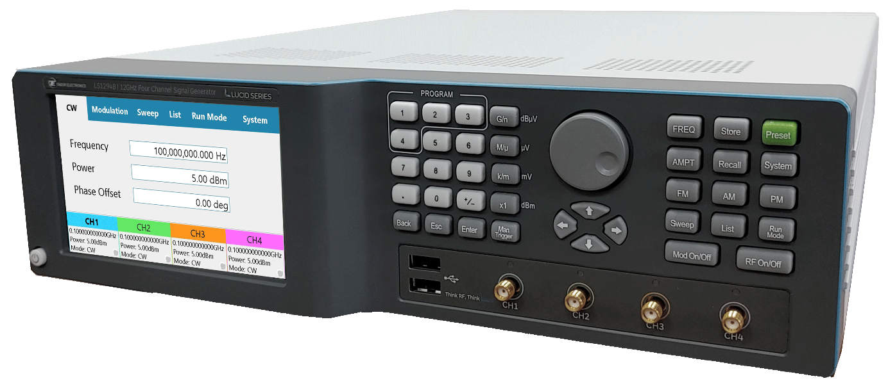

Figure ‎1.1 LS1294B – 12GHz Four Channel RF Analog Signal Generator Benchtop

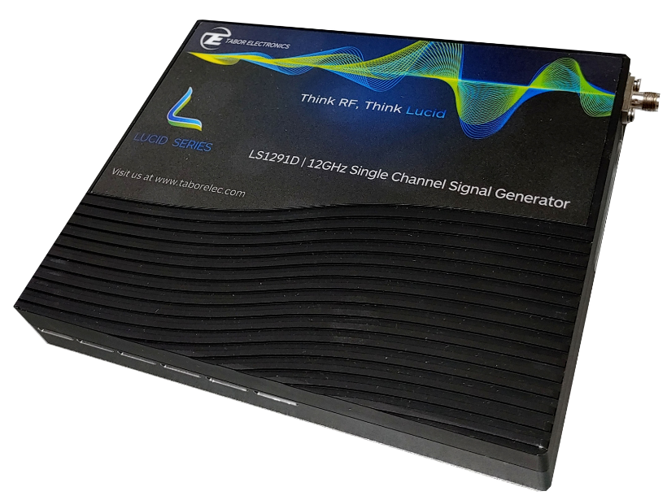

Figure ‎1.2 LSX4091D – 12GHz RF Analog Signal Generator Desktop

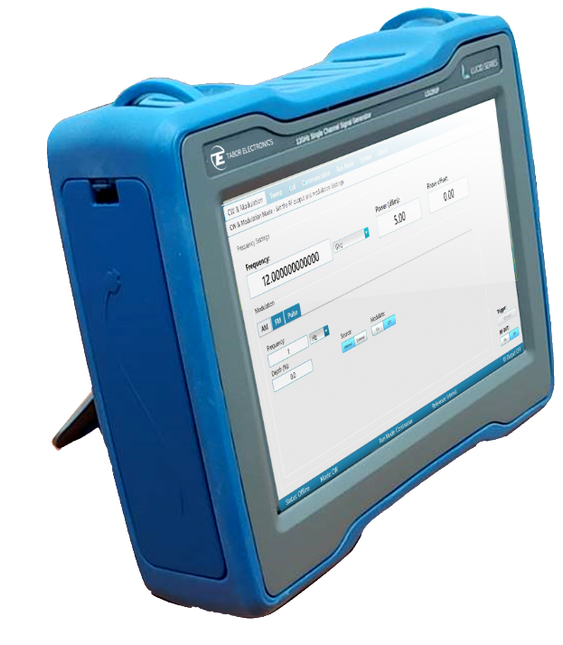

Figure ‎1.3 LSX4091P – 12GHz One Channel RF Analog Signal Generator Portable

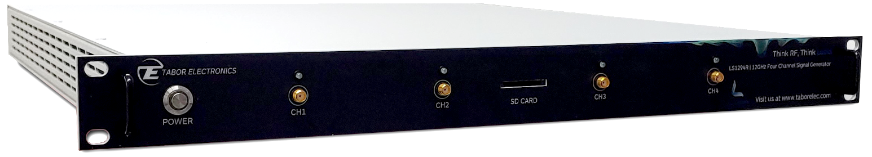

Figure ‎1.4 LS1294R – 12GHz Four Channel RF Analog Signal Generator Rackmount

Caution!

The procedures described in this section are for use only by qualified service personnel. Do not remove instrument covers as it may affect product characteristics and temperature.

Caution!

Always perform performance tests in a static safe workstation.

## Lucid Series Devices

The tables below list the validated Lucid devices. The validation also includes all the applicable device options.

Table . Validated Lucid Benchtop Devices

|  |  |
| --- | --- |
| Model | Description |
| LS3081B | 3 GHz, 1 channel, benchtop RF analog signal generator |
| LS3082B | 3 GHz, 2 channels, benchtop RF analog signal generator |
| LS3084B | 3 GHz, 4 channels, benchtop RF analog signal generator |
| LS6081B | 6 GHz, 1 channel, benchtop RF analog signal generator |
| LS6082B | 6 GHz, 2 channels, benchtop RF analog signal generator |
| LS6084B | 6 GHz, 4 channels, benchtop RF analog signal generator |
| LSX4091B | 12 GHz, 1 channel, benchtop RF analog signal generator |
| LS1292B | 12 GHz, 2 channels, benchtop RF analog signal generator |
| LS1294B | 12 GHz, 4 channels, benchtop RF analog signal generator |

Table . Validated Lucid Desktop Devices

|  |  |
| --- | --- |
| Model | Description |
| LS3081D | 3 GHz, 1 channel, desktop RF analog signal generator |
| LS6081D | 6 GHz, 1 channel, desktop RF analog signal generator |
| LSX4091D | 12 GHz, 1 channel, desktop RF analog signal generator |

Table . Validated Lucid Portable Devices

|  |  |
| --- | --- |
| Model | Description |
| LS3081P | 3 GHz, 1 channel, portable RF analog signal generator |
| LS6081P | 6 GHz, 1 channel, portable RF analog signal generator |
| LSX4091P | 12 GHz, 1 channel, portable RF analog signal generator |

Table . Validated Lucid Rackmount Devices

|  |  |
| --- | --- |
| Model | Description |
| LS3081R | 3 GHz, 1 channel, rack-mounted RF analog signal generator |
| LS3082R | 3 GHz, 2 channels, rack-mounted RF analog signal generator |
| LS3084R | 3 GHz, 4 channels, rack-mounted RF analog signal generator |
| LS30816R | 3 GHz, 16 channels, rack-mounted RF analog signal generator |
| LS6081R | 6 GHz, 1 channels, rack-mounted RF analog signal generator |
| LS6082R | 6 GHz, 2 channels, rack-mounted RF analog signal generator |
| LS6084R | 6 GHz, 4 channels, rack-mounted RF analog signal generator |
| LS60816R | 6 GHz, 16 channels, rack-mounted RF analog signal generator |
| LSX4091R | 12 GHz, 1 channel, rack-mounted RF analog signal generator |
| LS1292R | 12 GHz, 2 channels, rack-mounted RF analog signal generator |
| LS1294R | 12 GHz, 4 channels, rack-mounted RF analog signal generator |
| LSX40916R | 12 GHz, 16 channels, rack-mounted RF analog signal generator |

Table . Validated Lucid Module Devices

|  |  |
| --- | --- |
| Model | Description |
| LS3081M | 3 GHz, 1 channel, module RF analog signal generator |
| LS6081M | 6 GHz, 1 channel, module RF analog signal generator |
| LSX4091M | 12 GHz, 1 channel, module RF analog signal generator |

## Qualification Procedure

The following the specifications and performance verification tests verifies that the Lucid Series device is working according to specifications.

## Environmental Conditions

Tests should be performed under laboratory conditions having an ambient temperature of 25°C, ±5°C and at relative humidity of less than 80%. If the instrument has been subjected to conditions outside these ranges, allow at least one additional hour for the instrument to stabilize before beginning the tests.

## Warm-up Period

Most equipment is subject to a small amount of drift when it is first turned on. To ensure accuracy, turn on the power to the Model LSX4091 and allow it to warm-up for at least 30 minutes before beginning the tests.

## Initial Instrument Setting

To avoid confusion as to which initial setting is to be used for each test, it is required that the instrument be reset to factory default values prior to each test. To reset the LSX4091 to factory defaults, use the Factory Rest command.

## Recommended Test Equipment

Recommended test equipment for troubleshooting, calibration and performance checking is listed in the table below. Test instruments other than those listed may be used only if their specifications equal or exceed the required characteristics.

Table . Recommended Test Equipment

|  |  |  |
| --- | --- | --- |
| Equipment | Model No. | Manufacturer |
| Oscilloscope | MSOS404A | Keysight |
| Frequency Counter | 53132A | Keysight |
| Spectrum Analyzer | N9000A | Keysight |
| Arbitrary Pulse Generator | PM8571A | Tabor |
| Power Meter | E4418B | Keysight |
| Signal Source Analyzer | E5052B | Keysight |

## Test Procedures

Use the following procedures to check the LSX4091 against the specifications. A complete set of specifications is listed in the LSX4091 user manual. The following paragraphs show how to set up the instrument for the test, what the specifications for the tested function are, and what acceptable limits for the test are. If the instrument fails to perform within the specified limits, the instrument must be calibrated or tested to find the source of the problem.

## Default Setup

* Frequency: 1 GHz
* Phase: 0
* Power: 5 dBm
* RF Output: OFF
* Pulse Modulation: OFF
* Pulse Modulation Source: Int
* Pulse Modulation Frequency:1 MHz
* Pulse Modulation Width: 500 μs
* FM Modulation: OFF
* FM Modulation Source: Int
* FM Modulation Frequency: 100 kHz
* FM Deviation: 1 MHz
* AM Modulation: OFF
* AM Modulation Source: Int
* AM Modulation Frequency: 10 kHz
* AM Depth: 50%
* Frequency Sweep: OFF
* Frequency Sweep Start: 1 GHz
* Frequency Sweep Stop: 2 GHz
* Frequency Sweep Steps: 1000
* Frequency Sweep Step Time: 1 ms
* Frequency Sweep Direction: Up
* Power Sweep: OFF
* Power Sweep Start: -5 dBm
* Power Sweep Stop: 5 dBm
* Power Sweep Steps: 10
* Power Sweep Step Time : 1 ms
* Power Sweep Direction: Up
* List Enable: OFF
* Run Mode: Continuous
* Trigger Source: External
* Trigger Count: 1
* Trigger Timer: 1 ms

## Related Documentation

* Lucid Programming Manual
* Lucid Control Panel User Manual
* Lucid Benchtop/Desktop/Portable/Rackmount User Manual

# Test Plan

**Devices used for testing –**

1. **LUCID model- LSX 2091M**
2. **External source – Tabor Waveform generator WW1072**
3. **Spectrum analyzer – PSA series spectrum analyzer E4440A**

**\*\*\*All tests are performed spectrum analyzer to check the scripts and functionality.**

Notes

The test plan is written for the 40GHz module, but is also applicable for the 20GHz modules.  
The test plan is written for the 1 channel module, but it should be applied for all channels when relevant.  
The text refers to LSX4091, but it is interchangeable for your specific instrument module.

## Frequency Accuracy

Test Equipment Counter

Preparation:

1. Configure the counter as follows:
   1. Termination: 50Ω, DC coupled
   2. Connect the LSX4091 output to the counter input channel 1
   3. Connect the LSX4091 10MHz output Ref to the counter 10MHz Ref input
2. Configure the LSX4091 as follows:
   1. Frequency: 100 kHz
   2. Output: On

Test Procedure:

1. Perform frequency Accuracy tests according to the table below.
2. Increase output frequency up to 1 MHz within 100 kHz resolution and repeat Test Procedure 1 for each frequency
3. Repeat Test Procedure 1 for 10MHz, 50MHz, 100MHz, 1GHz and 3GHz output frequency

Table . Frequency Accuracy

|  |  |  |  |  |  |
| --- | --- | --- | --- | --- | --- |
| Test Number | Output Frequency | Error Limits | Spetrum Reading | Pass | Fail |
| 1 | 100 kHz | ±10 mHz | 100.0 kHz |  |  |
| 2 | 200 kHz | ±10 mHz | 200.4 kHz |  |  |
| 3 | 300 kHz | ±10 mHz | 300.000 kHz |  |  |
| 4 | 400 kHz | ±10 mHz | 400.000 kHz |  |  |
| 5 | 500 kHz | ±10 mHz | 500.000 kHz |  |  |
| 6 | 600 kHz | ±10 mHz | 600.000 kHz |  |  |
| 7 | 700 kHz | ±10 mHz | 700.000 kHz |  |  |
| 8 | 800 kHz | ±10 mHz | 800.000 kHz |  |  |
| 9 | 900 kHz | ±10 mHz | 900.000 kHz |  |  |
| 10 | 1 MHz | ±10 mHz | 1.000000 MHz |  |  |
| 11 | 10 MHz | ±100 mHz | 10.000003 MHz |  |  |
| 12 | 50 MHz | ±100 mHz | 50.000012 MHz |  |  |
| 13 | 100 MHz | ±100 mHz | 100.000 023 MHz |  |  |
| 14 | 1 G | ±100 mHz | 1.000000025 MHz |  |  |
| 15 | 3 GHz | ±0.3 kHz | 3.000000 MHz |  |  |
| 16 | 5 | ±0.3 kHz | 5.000000 MHz |  |  |
| 17 | 9 | ±0.3 kHz | 9.000000 MHz |  |  |
| 18 | 10 | ±0.3 kHz | 10.000000 MHz |  |  |
| 19 | 12 | ±0.3 kHz | 12.000000 MHz |  |  |
| 20 | 15 | ±0.3 kHz | 15.000000 MHz |  |  |
| 21 | 18 | ±0.3 kHz | 18.00000 MHz |  |  |
| 22 | 20 | ±0.3 kHz | 20.000000 MHz |  |  |

## Frequency Resolution

Test Equipment: Counter

Preparation:

1. Configure the counter as follows:
   1. Gate: DIGITS
   2. DIGITS: as specified in the test
   3. Measurement: Frequency 1
2. Connect the LSX4091 10MHz output Ref to the counter 10MHz Ref input
3. Connect the LSX4091 output to the counter input channel 1
4. Configure the LSX4091 as follows:
   1. Frequency as specified in the test
   2. Output: On

Test Procedure:

1. Perform frequency resolution tests by reading the requested frequency listed in the table below, increase the frequency by 1mHz and then read and verify that the frequency changed by 1mHz

Table . Frequency Accuracy

|  |  |  |  |  |  |  |
| --- | --- | --- | --- | --- | --- | --- |
| Test Number | Output Frequency | Counter Digits Number | Reference Frequency | Delta Frequency Counter Reading | Pass | Fail |
| 1 | 100 MHz | 11 | 100.00 MHz | 0.00 MHz |  |  |
| 2 | 100 MHz+0.001 |  | 100.0000 MHz | - |  |  |
| 3 | 100 MHz+0.002 |  | 100.0000 MHz | - |  |  |

## Output Power vs. Frequency

Test Equipment: Power Meter

Preparation:

1. Connect the LSX4091 output to the power meter input
2. Configure the LSX4091 as follows:
   1. Frequency as specified in the test
   2. Output: On
   3. Power: 15dBm

Test Procedure:

1. Perform output power test according to the table below
2. Decrease the power by 1dB and perform the test again
3. Repeat step 2 down to power of -20 dBm
4. Select the next frequency and repeat steps 1 to 3
   1. 0.1 MHz ≤ frequency ≤ 1 MHz; increment size of 0.1 MHz (10 frequencies)
   2. 2 MHz ≤ frequency ≤ 10 MHz; increment size of 1 MHz (9 frequencies)
   3. 20 MHz ≤ frequency ≤ 8000 MHz; increment size of 10 MHz (798 frequencies)
   4. 8000 MHz ≤ frequency ≤ 40000 MHz; increment size of 100 MHz (320 frequencies)

Table . Power vs. Frequency

|  |  |  |  |  |  |  |
| --- | --- | --- | --- | --- | --- | --- |
| Test Number | Output Frequency | Output Power | Error Limits | Power Reading | Pass | Fail |
| 1 | 100 kHz | 15 dBm | ±0.5 dB | -46 |  | FAIL |
| 2 | 100 kHz | 5 | ±0.5 dB | -27 |  | FAIL |
| 3 | 100 kHz | 0 |  | -33 |  | FAIL |
| 4 | 100 kHz | 20 |  | -33 |  | FAIL |
| 40896 | 40 GHz | 15 dBm | ±1.0 dB |  |  | FAIL |
| 40932 | 40 GHz | -20 dBm | ±1.0 dB |  |  | FAIL |

## Ref In

Test Equipment: Scope, Signal Generator

Preparation:

1. Connect the LSX4091 output to the scope channel 1 input
2. Connect the signal generator 10MHz Ref output to the scope channel 2 input
3. Connect the signal generator output to the LSX4091 Ref In input
4. Set the signal generator output ON and configure it as specified in the test table.
5. Configure the LSX4091 as follows:
   1. Frequency: 10 MHz
   2. Output: On
   3. Power: 5 dBm

Test Procedure:

1. Perform Ref In tests using Table 5 by verified that the phase between the LSX4091 output and the signal generator 10MHz Ref out is locked:   
   Measure delta between min and max tolerance: ±1.5ns
2. Increase the signal generator power as requested in the test and perform Ref In tests again

Table . Ref In

|  |  |  |  |  |
| --- | --- | --- | --- | --- |
| Test Number | Signal Generator Frequency | Signal Generator Power | Pass | Fail |
| 1 | 100 MHz | -5 dBm | 6.66 | FAIL |
| 2 | 100 MHz | 0 dBm | 6.66 | FAIL |
| 3 | 100 MHz | 10 dBm | 6.67 | FAIL |
| 4 | 10 MHz | -5 dBm | 0.82 | FAIL |
| 5 | 10 MHz | 0 dBm | 0.83 | FAIL |
| 6 | 10 MHz | 10 dBm | 0.83 | FAIL |

## Ref Out

Test Equipment: Scope

Preparation:

1. Connect the LSX4091 10 MHz Ref out to the scope channel 1 input
2. Connect the LSX4091 output the scope channel 2 input
3. Configure the LSX4091 P as follows:
   1. Output: ON
   2. Frequency: 10 MHz

Test Procedure:

1. Perform Ref Output tests using Table 6 by verified that the phase between the LSX4091 output and Ref Output is locked.
2. Measure delta between min and max tolerance: ±1ns
3. Connect the LSX4091 100 MHz Ref output to the scope channel 1 input.
4. Change the LSX4091 output frequency to 100MHz and verified that the phase between the LSX4091 output and Ref Output is looked.

Table . RefClkOut

|  |  |  |  |
| --- | --- | --- | --- |
| Ref Out Frequency | Output Frequency | Pass | Fail |
| 10 MHz | 10 MHz |  | FAIL |
| 100 MHz | 100 MHz |  | FAIL |

## Harmonic Distortion

Test Equipment: Spectrum Analyzer

Preparation:

1. Configure the Spectrum as follows:
   1. Measurement: Harmonic Distortion
2. Connect the LSX4091 output to the spectrum input
3. Configure the LSX4091 as follows:
   1. Output: On
   2. Frequency: As specified in the test
   3. Power: As specified in the test

Test Procedure:

1. Perform Harmonic Distortion tests according to the table below.
2. Select the next frequency and repeat step 1
   1. 10 MHz ≤ frequency ≤ 1000 MHz; increment size of 10 MHz (100 frequencies)
   2. 1100 MHz ≤ frequency ≤ 8000 MHz; increment size of 100 MHz (69 frequencies)
   3. 8100 MHz ≤ frequency ≤ 20000 MHz; increment size of 100 MHz (119 frequencies)
   4. 20100 MHz ≤ frequency ≤ 40000 MHz; increment size of 100 MHz (199 frequencies)

Table . Harmonic Distortion

|  |  |  |  |  |  |  |
| --- | --- | --- | --- | --- | --- | --- |
| S No. | Input Frequency | Output frequency | Power 1st Harmonic | Power 2nd Harmonic | Error | S No. |
| 1 | 50 KHz | 50 KHz | -33.36 dBm | -62.77 dBm |  | 1 |
| 2 | 100 KHz | 100 KHz | -28.42 dBm | -61.61 dBm |  | 2 |
| 3 | 500 KHz | 500 KHz | -14.02 dBm | -62.8 dBm |  | 3 |
| 4 | 1 MHz | 1 MHz | -8.36 dBm | -59.60 dBm |  | 4 |
| 5 | 5MHz | 5MHz | 2.56 dBm | -45.8 dBm |  | 5 |
| 6 | 10 MHz | 10 MHz | 4.21 dBm | -43.5 dBm |  | 6 |
| 7 | 200MHz | 190 MHz | 4.61 dBm | -42.64 dBm |  | 7 |
| 8 | 500 MHz | 498 MHz | 5.03 dBm | --48.08 dBm |  | 8 |
| 9 | 1GHz | 1 GHz | 5.31 dBm | -38.78 dBm |  | 9 |
| 10 | 5GHz | 5 GHz | 4.91 dBm | -29.57 dBm |  | 10 |
| 11 | 8 GHz | 7.96 GHz | 1.81 dBm | -41.14 dBm |  | 11 |
| 12 | 12GHz | 12.02 GHz | 3.15 dBm | -34.31 dBm |  | 12 |

## Spurious In-Band Test

Test Equipment: Spectrum Analyzer

Preparation:

1. Configure the Spectrum as follows:
   1. Start frequency: As specified in the test
   2. Stop frequency: As specified in the test
   3. Res BW: 30 kHz
2. Connect the LSX4091 output to the spectrum input
3. Configure the LSX4091 as follows:
   1. Frequency: As specified in the test
   2. Output: On
   3. Power: 5 dBm.

Test Procedure:

1. Perform Spurious tests according to the table below.

Table . Spurious

|  |  |  |  |  |  |  |  |
| --- | --- | --- | --- | --- | --- | --- | --- |
| S No. | Output frequency | Start frequency | Stop frequency | Max spurious frequency | Max spurious power | Pass/Fail | S No. |
| 1 | 1000 | 500 | 1500 | 1363 | -72.76 | Pass | 1 |
| 2 | 2000 | 1500 | 2400 | 2364 | -68.12 | Pass | 2 |
| 3 | 3500 | 2400 | 3400 | 3137 | -70.47 | Pass | 3 |
| 4 | 4000 | 2400 | 3400 | 3000 | -70.28 | Pass | 4 |
| 5 | 550 | 3400 | 3900 | 3643 | -77.79 | Pass | 5 |
| 6 | 2300 | 3900 | 4900 | 4600 | -51.24 | fail | 6 |
| 7 | 1500 | 4900 | 5900 | 5223 | -81.15 | Pass | 7 |
| 8 | 3500 | 5900 | 6900 | 6637 | -71.22 | Pass | 8 |
| 9 | 4000 | 5900 | 7900 | 6800 | -78.14 | Pass | 9 |
| 10 | 3500 | 6900 | 7900 | 7000 | -28.86 | fail | 10 |
| 11 | 4000 | 6900 | 7900 | 7220 | -77.63 | Pass | 11 |
| 12 | 550 | 7900 | 8900 | 8563 | -78.30 | Pass | 12 |
| 13 | 2300 | 8900 | 9900 | 9200 | -63.0444 | Pass | 13 |
| 14 | 1500 | 9900 | 10900 | 10500 | -59.312 | fail | 14 |
| 15 | 3500 | 10900 | 11900 | 11890 | -76.42 | Pass | 15 |
| 16 | 4000 | 10900 | 11900 | 11487 | -78.80 | Pass | 16 |

## Spurious Next to Carrier

Test Equipment: Spectrum Analyzer

Preparation:

1. Configure the Spectrum as follows:
   1. Center Frequency: as specified in the test
   2. Res BW: 200 kHz
   3. Video BW: 400 Hz
2. Connect the LSX4091 output to the spectrum input
3. Configure the LSX4091 as follows:
   1. Frequency: As specified in the test
   2. Output: On
   3. Power: 5 dBm.

Test Procedure:

1. Perform Spurious tests using Table 9
2. Select the next frequency and repeat steps 1  
   20 MHz ≤ frequency ≤ 100 MHz; increment size of 10 MHz  
   Spectrum Frequency Span: 20 MHz  
   150 MHz ≤ frequency ≤ 1000 MHz; increment size of 50 MHz  
   Spectrum Frequency Span: 30 MHz  
   1250 MHz ≤ frequency ≤ 12000 MHz; increment size of 250 MHz  
   Spectrum Frequency Span: 40 MHz

Table . Spurious

|  |  |  |  |  |  |
| --- | --- | --- | --- | --- | --- |
| Test Step | Output Frequency (MHz) | Error Limits | Max Spurious Reading | Pass | Fail |
| 1 | 20 | -60 dBc |  |  |  |
| 2 | 30 | -60 dBc |  |  |  |
| 70 | 11750 | -60 dBc |  |  |  |
| 71 | 12000 | -60 dBc |  |  |  |

## Phase Noise

Test Equipment: Signal Source Analyzer (SSA)

Preparation:

1. Configure the SSA as follows:
   1. Carrier frequency: as specified by the test
   2. Res BW: 1E5
   3. Start Frequency: 100
   4. Stop Frequency: 30 MHz
   5. Correlation Count: 5
   6. Measurement: Phase Noise at 10kHz offset
2. Connect the LSX4091 output to the SSA input
3. Configure the LSX4091 as follows:
   1. Frequency: As specified by the test
   2. Output: On
   3. Power: 5 dBm

Test Procedure:

1. Perform Phase Noise tests according to the table below.
2. Select the next frequency and repeat steps 1

Table . Phase Noise

|  |  |  |  |  |  |
| --- | --- | --- | --- | --- | --- |
| Test Step | Output Frequency | Error Limits | Phase Noise Reading | Pass | Fail |
| 1 | 100 MHz | -155 dBc/Hz |  |  |  |
| 2 | 250 MHz | -147 dBc/Hz |  |  |  |
| 3 | 500 MHz | -141 dBc/Hz |  |  |  |
| 4 | 1 GHz | -134 dBc/Hz |  |  |  |
| 5 | 2 GHz | -128 dBc/Hz |  |  |  |
| 6 | 4 GHz | -123 dBc/Hz |  |  |  |
| 7 | 8 GHz | -116 dBc/Hz |  |  |  |
| 8 | 10 GHz | -115 dBc/Hz |  |  |  |
| 9 | 20 GHz | -109 dBc/Hz |  |  |  |
| 10 | 40 GHz | -103 dBc/Hz |  |  |  |

## External Trigger Input

Test Equipment: Scope, Function Generator

Preparation:

1. Connect the LSX4091 output to the scope channel 1 input
2. Split the Function Generator output and connect it to the LSX4091 Trigger input and scope channel 2 input
3. Configure the Function Generator as follows:
   1. Function shape: Square
   2. Frequency: 10 kHz
   3. Duty Cycle: 20 %
   4. Amplitude: 4Vpp
   5. Offset: 2V
   6. Output: ON
4. Configure the LSX4091 as follows:
   1. Output: ON
   2. AM Modulation: ON
   3. Modulation Frequency: 100kHz
   4. Modulation Depth: 50%
   5. Run Mode: Trigger
   6. Trigger Source: External
   7. Trigger Edge: As specified by the test

Test Procedure:

1. Perform External Trigger tests according to the table below.

Table . External Trigger

|  |  |  |
| --- | --- | --- |
| Trigger Edge | Pass | Fail |
| Positive | PASS |  |
| Negative | PASS |  |

## Internal Trigger

Test Equipment: Scope

Preparation:

1. Connect the LSX4091 output to the scope channel 1 input
2. Configure the scope as follows:
   1. Amplitude: 500 mV per division
   2. Time base: 50% of the LSX4091 Trigger Timer
   3. Trigger mode: Triggered
   4. Trigger Level: 0.5
3. Configure the LSX4091 as follows:
   1. Output: ON
   2. Frequency: 100 MHz
   3. Run Mode: Trigger
   4. Trigger Source: Internal
   5. Trigger Timer: As specified by the test
   6. AM Modulation: ON
   7. Modulation Frequency: 100 kHz
   8. Modulation Depth: 50%

Test Procedure:

1. Perform the Internal Trigger tests according to the table below.
2. Measure the delay between two nearby output signals.

Table . Internal Trigger

|  |  |  |  |  |  |
| --- | --- | --- | --- | --- | --- |
| Timer | Trigger Period Limit | Delay Reading | Am freq | Pass | Fail |
| 1 ms | 1msec ± 10nsec |  | 101KHz |  |  |
| 100 µs | 100µsec ± 10nsec |  | 99KHz |  |  |

## List Mode

Test Equipment: Scope

Preparation:

1. Connect the LSX4091 output to the scope channel 1 input
2. Configure the scope as follows:
   1. Amplitude: 200 mV per division
   2. Time base: 100 µs per division
   3. Trigger: Normal
   4. Trigger edge: Rise
3. Configure the LSX4091 as follows:
   1. Output: ON
   2. Run mode: List
   3. List step 1: Frequency 1 GHz, Power 0dBm, Dwell 500 µs
   4. List step 2:Frequency 2 GHz, Power 0dBm, Dwell 500 µs
   5. List step 3: Frequency 3 GHz, Power 0dBm, Dwell 500 µs

Test Procedure:

1. Perform List Mode tests according to the table below.
2. Measure the frequency of each step.

Table . List Mode - Frequency Switching Speed

|  |  |  |  |
| --- | --- | --- | --- |
| Switching time Limit | Switching time Reading | Pass | Fail |
| 500 µs ± 10nsec |  | PASS |  |

1. Configure the LSX4091 as follows:
   1. List step 1: Frequency 1 GHz, Power 5dBm, Dwell 500 us
   2. List step 2: Frequency 2 GHz, Power 0dBm, Dwell 1000 us
   3. List step 3: Frequency 3 GHz, Power -5dBm, Dwell 1500 us
2. Perform List Mode Frequency, Power and Dwell tests according to the table below.

Table . List Mode - Frequency

|  |  |  |  |  |  |  |  |
| --- | --- | --- | --- | --- | --- | --- | --- |
| Frequency | Power | Dwell time | Frequency Reading | Power Reading | Dwell time Reading | Pass | Fail |
| 1 GHz | 5dBm | 500 µs | 0.995 GHz | 5.38 |  | PASS |  |
| 2 GHz | 0dBm | 1000 µs | 2.008 GHz | -0.39 |  |
| 3 GHz | -5dBm | 1500 µs | 3.000 GHz | -3.32 |  |

## Frequency Modulation

Test Equipment: Scope with Jitter analysis, Function Generator

Preparation:

1. Connect the LSX4091 output to the scope channel 1 input
2. Connect the function generator output to the LSX4091M FM input
3. Configure the scope as follows:
   1. Amplitude: 200 mV per division
   2. Time base: 100 us per division
   3. Jitter analysis: ON
4. Configure the function generator as follows:
   1. Amplitude: 1 Vpp
   2. Frequency: 1 MHz
   3. Output: ON
5. Configure the LSX4091 as follows:
   1. Output: ON
   2. FM modulation: ON
   3. Frequency deviation: 5 MHz
   4. Modulation source: External

Test Procedure:

1. Perform Frequency Modulation tests according to the table below.

Table . Frequency Modulation – External Source

|  |  |  |  |
| --- | --- | --- | --- |
| Frequency Deviation Reading | Modulation Frequency Reading | Pass | Fail |
|  |  |  |  |

1. Configure the function generator as follows:
   1. Output: OFF
2. Configure the LSX4091 as follows:
   1. Modulation Frequency: 1 MHz
   2. Modulation source: Internal

Test Procedure:

1. Perform Frequency Modulation tests according to the table below.

Table . Frequency Modulation –Internal Source

|  |  |  |  |
| --- | --- | --- | --- |
| Frequency Deviation Reading | Modulation Frequency Reading | Pass | Fail |
|  |  |  |  |

## Amplitude Modulation

Test Equipment: Scope, Function Generator

Preparation:

1. Connect the LSX4091 output to the scope channel 1 input
2. Connect the function generator output to the LSX4091M AM input
3. Configure the scope as follows:
   1. Amplitude: 500 mV per division
   2. Time base: 5 us per division
4. Configure the function generator as follows:
   1. Amplitude: 1 Vpp
   2. Frequency: 100 kHz
   3. Output: ON
5. Configure the LSX4091 as follows:
   1. Output: ON
   2. AM modulation: ON
   3. Modulation source: External

Test Procedure:

1. Perform Frequency Modulation tests according to the table below.

Table . Amplitude Modulation – External Source

|  |  |  |  |
| --- | --- | --- | --- |
| Modulation Depth Reading | Modulation Frequency Reading | Pass | Fail |
|  |  | PASS |  |

1. Configure the function generator as follows:
   1. Output: OFF
2. Configure the LSX4091 as follows:
   1. Modulation source: Internal
   2. Modulation Frequency: 100 kHz
   3. Modulation Depth: 75%

Test Procedure:

1. Perform Frequency Modulation tests according to the table below.

Table . Amplitude Modulation – Internal Source

|  |  |  |  |
| --- | --- | --- | --- |
| Modulation Depth Reading | Modulation Frequency Reading | Pass | Fail |
|  |  | PASS |  |

## Pulse Modulation

Test Equipment: Scope, Function Generator

Preparation:

1. Connect the LSX4091 output to the scope channel 1 input
2. Connect the function generator output to the LSX4091M Pulse input
3. Configure the scope as follows:
   1. Amplitude: 200 mV per division
   2. Time base: 100 µs per division
4. Configure the function generator as follows:
   1. Function shape: Square
   2. Amplitude: 1 Vpp
   3. Offset: 1V
   4. Output: ON
   5. Duty Cycle: As specified in the test
   6. Frequency: As specified in the test
5. Configure the LSX4091 as follows:
   1. Output: ON
   2. Pulse modulation: ON
   3. Modulation source: External

Test Procedure:

1. Perform Frequency Modulation tests according to the table below.

Table . Pulse Modulation – External Source

|  |  |  |  |  |  |
| --- | --- | --- | --- | --- | --- |
| Function Generator Duty Cycle | Function Generator Frequency | Pulse Duration Reading | Pulse Repetition Reading | Pass | Fail |
| 50% | 1 MHz |  | 1Mhz |  |  |
| 30 % | 10 MHz |  | 10MHz |  |  |

1. Configure the function generator as follows:
   1. Output: OFF
2. Configure the LSX4091 as follows:
   1. Modulation source: Internal
   2. Pulse Width: As specified in the test
   3. Pulse Repetition Rate: As specified in the test

Test Procedure:

1. Perform Frequency Modulation tests according to the table below.

Table . Pulse Modulation – Internal Source

|  |  |  |  |  |  |
| --- | --- | --- | --- | --- | --- |
| Pulse Width | Pulse Repetition | Frequency Deviation Reading | Modulation Frequency Reading | Pass | Fail |
| 500 ns | 1 MHz |  |  | PASS |  |
| 30 ns | 10 MHz |  |  | PASS |  |

## EPR Option - Output Power vs Frequency

Test Equipment: Spectrum

Preparation:

1. Connect the LSX4091 output to the power meter input
2. Configure the LSX4091 as follows:
   1. Spectrum: Minimum span
   2. Frequency: As specified in the test
   3. Output: On
   4. Power: As specified in the test

Test Procedure:

1. Perform output power test according to the table below.

Table . Power vs Frequency

|  |  |  |  |  |  |  |
| --- | --- | --- | --- | --- | --- | --- |
| Test Number | Output Frequency | Output Power | Error Limits | Power Reading | Pass | Fail |
| 1 | 1 MHz | 25 dBm | ±0.5 dB |  |  |  |
| 2 | 1 MHz | 0 dBm | ±0.5 dB |  |  |  |
| 3 | 1 MHz | -70 dBm | ±0.5 dB |  |  |  |
| 4 | 1 MHz | -120 dBm | ±0.5 dB |  |  |  |
| 5 | 100 MHz | 25 dBm | ±0.5 dB |  |  |  |
| 6 | 100 MHz | 0 dBm | ±0.5 dB |  |  |  |
| 7 | 100 MHz | -70 dBm | ±0.5 dB |  |  |  |
| 8 | 100 MHz | -120 dBm | ±0.5 dB |  |  |  |
| 9 | 1 GHz | 25 dBm | ±0.5 dB |  |  |  |
| 10 | 1 GHz | 0 dBm | ±0.5 dB |  |  |  |
| 11 | 1 GHz | -70 dBm | ±0.6 dB |  |  |  |
| 12 | 1 GHz | -120 dBm | ±0.6 dB |  |  |  |
| 13 | 3 GHz | 25 dBm | ±0.5 dB |  |  |  |
| 14 | 3 GHz | 0 dBm | ±0.5 dB |  |  |  |
| 15 | 3 GHz | -70 dBm | ±0.6 dB |  |  |  |
| 16 | 3 GHz | -120 dBm | ±0.6 dB |  |  |  |
| 17 | 6 GHz | 25 dBm | ±0.7 dB |  |  |  |
| 18 | 6 GHz | 0 dBm | ±0.7 dB |  |  |  |
| 19 | 6 GHz | -70 dBm | ±1.0 dB |  |  |  |
| 20 | 6 GHz | -120 dBm | ±1.0 dB |  |  |  |
| 21 | 12 GHz | 25 dBm | ±1.0 dB |  |  |  |
| 22 | 12 GHz | 0 dBm | ±1.0 dB |  |  |  |
| 23 | 12 GHz | -70 dBm | ±1.5 dB |  |  |  |
| 24 | 12 GHz | -120 dBm | ±1.5 dB |  |  |  |